MOBILE APP DEVELOPMENT CAPSTONE
CareLink
System Analysis and Design Document
Patient records for rural clinics: Flutter app with a FastAPI backend

Group members | Kirabira Mohammad Elias  Makabugo J. Shafic
Backend lead | Kirabira Mohammad Elias (241-21301-8051
Flutter lead | Kaddu Suudi
Analyst and integration lead | Makabugo J. Shafic & Mohammad Elias
Repository | https://github.com/mek-poems25/flutter2026.git
Submitted | 24 October 2026

1. Problem Statement
Health workers in rural clinics and outreach camps in Uganda often work with slow, unreliable or no internet. Patient details are written on paper, so records are lost, duplicated, or reach the clinic’s main records too late to help with follow-up visits. The people affected are the community health workers and nurses who register and treat patients, and the supervisors who need accurate, up-to-date records.
CareLink is a mobile app backed by its own server. A health worker logs in, registers patients and records visits from a phone, and every record is stored safely on the server. The app keeps working when the connection drops: changes are held on the phone and uploaded when the connection returns. If a record was changed somewhere else in the meantime, the server does not silently overwrite either version. It keeps both and asks a person to choose. This protects against lost clinical information, which on paper or in simple apps goes unnoticed.
Scope for this capstone: one Flutter app and one FastAPI backend with a relational database. Direct phone-to-phone sharing over Bluetooth or Wi-Fi is outside this capstone.

2. Users and Their Goals
User | Description | Goals
Health worker (role: worker) | Nurse or community health worker using a personal phone, often with poor signal | Register an account and log in securely; register patients quickly; record visits; find a patient by name or village; fix mistakes; keep working when the connection drops; see and resolve clashing edits
Clinic supervisor (role: admin) | Person in charge of records at a clinic (bonus feature) | View all patients registered by workers at the same clinic; review open conflicts; trust that no edit has been lost

3. Requirements

3.1 Functional requirements
ID | Requirement
FR1 | The system shall allow a new user to register with full name, email, password and clinic.
FR2 | The system shall store passwords only as bcrypt hashes and never as plain text.
FR3 | The system shall allow a registered user to log in with email and password and shall return an access token (JWT).
FR4 | The system shall reject any request to a protected endpoint that has a missing, invalid or expired token, with status 401.
FR5 | The system shall allow a logged-in user to create a patient record, which belongs to that user.
FR6 | The system shall allow a user to list and search only the patients that belong to them, by name or village.
FR7 | The system shall allow a user to view the details of one of their patients and return 404 if it does not exist.
FR8 | The system shall allow a user to update a patient record and shall require the version number the edit is based on.
FR9 | The system shall allow a user to delete one of their patients together with that patient’s visits.
FR10 | The system shall allow a user to record, list, edit and delete visits for their patients.
FR11 | The system shall validate all input and return status 400 with a clear message for invalid data.
FR12 | The system shall detect when an edit is based on an outdated version, shall return status 409, and shall store the rejected edit as a conflict instead of discarding it.
FR13 | The system shall allow a user to view their open conflicts and resolve each one by keeping the server version or applying their own edit.
FR14 | The app shall clear the stored token from the phone when the user logs out.
FR15 | The app shall display loading and error states, including a clear message when the server cannot be reached.
FR16 | (Bonus) The system shall allow an admin to view all patients of the users in the admin’s clinic.
FR17 | (Bonus) The app shall store changes made without a connection on the phone and upload them when the server is reachable again.

3.2 Non-functional requirements
ID | Category | Requirement
NFR1 | Usability on slow connections | The app shall show a loading indicator within 1 second of a request and shall time out after 15 seconds with a retry option, so it stays usable on a poor connection.
NFR2 | Security | Tokens shall expire after a fixed time (for example 60 minutes); passwords shall be hashed with bcrypt; users shall only access their own records.
NFR3 | Performance | List endpoints shall respond in under 2 seconds with 1,000 patients on a standard laptop.
NFR4 | Reliability | The app shall not crash when the server is off or returns an error; it shall show a readable message.
NFR5 | Maintainability | Flutter code shall be organised into models/, services/, screens/ and widgets/; the API shall be documented with Swagger/OpenAPI.
NFR6 | Privacy | Development and demonstration shall use synthetic patient data only.
NFR7 | Portability | The backend shall run on a laptop by following the README; the app shall run on Android phones and emulators.

4. User Stories
# | User story | Acceptance criteria
US1 | As a new health worker, I want to create an account so that I can use the app. | Registration succeeds with valid data; duplicate email and weak password are rejected with a message.
US2 | As a health worker, I want to log in so that my records stay private. | Correct details open the patient list; wrong details show an error; token is sent with every request.
US3 | As a health worker, I want to register a patient so that their details are stored. | Form validates required fields; new patient appears in my list.
US4 | As a health worker, I want to search patients by name or village so that I find them quickly. | Typing filters the list; only my patients appear.
US5 | As a health worker, I want to view a patient’s details and visit history so that I know their background. | Detail screen shows demographics and visits, newest first.
US6 | As a health worker, I want to edit a patient’s details so that I can correct mistakes. | Saving updates the record and increases its version.
US7 | As a health worker, I want to record a visit so that treatment is documented. | Visit saved with date, complaint and optional vitals; invalid values are rejected.
US8 | As a health worker, I want to delete a wrong patient or visit so that records stay accurate. | Confirmation is shown; the record disappears from the list.
US9 | As a health worker, I want to be told when my edit clashes with a newer change so that nothing is lost. | App shows a conflict message; both versions are kept.
US10 | As a health worker, I want to choose between my version and the server version so that I decide what is correct. | Conflict screen highlights differences; chosen version is saved and conflict closes.
US11 | As a health worker, I want a clear message when the server is off so that I know what to do. | Error state with a Retry button; app does not crash.
US12 | As a health worker, I want to log out so that nobody else can use my account. | Token is removed from the phone and the login screen appears.
US13 | As a clinic supervisor (bonus), I want to see all patients in my clinic so that I can review the clinic’s records. | Admin list includes patients of all users in the same clinic only.

5. Entity Relationship Diagram (ERD)
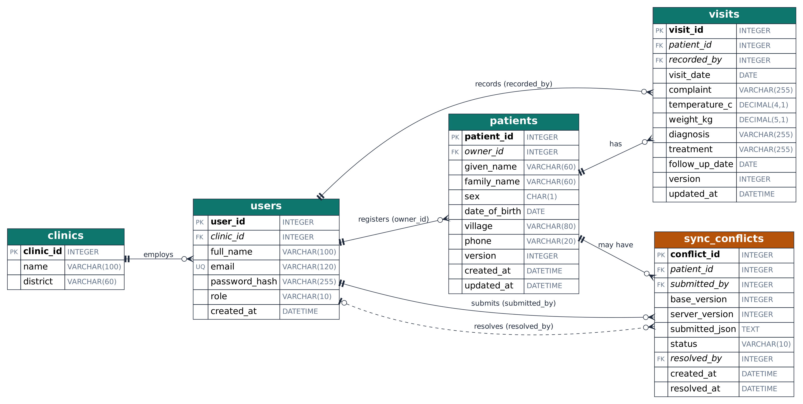
Figure 1. ERD. PK = primary key, FK = foreign key (italic), UQ = unique. Double bar = exactly one; circle with crow’s foot = zero or many. Dashed line = optional foreign key. Amber = conflict handling.

5.1 Relationships and cardinality
Parent (1) | Child (N) | Cardinality | Foreign key | Meaning
clinics | users | 1 : N | users.clinic_id | A clinic employs many users; each user belongs to one clinic
users | patients | 1 : N | patients.owner_id | A user registers many patients; each patient has one owner
patients | visits | 1 : N | visits.patient_id | A patient has many visits
users | visits | 1 : N | visits.recorded_by | A user records many visits
patients | sync_conflicts | 1 : N | sync_conflicts.patient_id | A patient may have many conflicts over time
users | sync_conflicts | 1 : N | sync_conflicts.submitted_by | A user may submit many rejected edits
users | sync_conflicts | 1 : N (optional) | sync_conflicts.resolved_by | A user may resolve many conflicts; empty until resolved

5.2 Normalisation (third normal form)
- 1NF. Every field holds a single value; no repeating groups. The rejected edit in sync_conflicts is stored as one JSON text value, treated as a single unit.
- 2NF. All tables have a single-column primary key, so no partial dependencies exist.
- 3NF. No non-key field depends on another non-key field. A patient’s clinic is not stored on patients because it can be found through the owner (patients.owner_id → users.clinic_id); storing it would create a transitive dependency. Clinic details live only in clinics.
- Many-to-many. The design has no many-to-many relationship, so no junction table is needed. If patients later need to be shared by several users, a patient_access junction table (patient_id, user_id) would be added.
Access rule: a worker can see only patients where owner_id is their own user_id, and their visits. An admin (bonus) can see patients whose owner belongs to the admin’s clinic.

6. Data Dictionary

clinics
Field | Type | Size | Constraints | Meaning
clinic_id | INTEGER | - | PK; Auto-increment primary key | Unique id of a clinic or outreach camp
name | VARCHAR | 100 | NOT NULL | Clinic name
district | VARCHAR | 60 | NOT NULL | District where the clinic is located

users
Field | Type | Size | Constraints | Meaning
user_id | INTEGER | - | PK; Auto-increment primary key | Unique id of a user
clinic_id | INTEGER | - | FK; References clinics(clinic_id), NOT NULL | Clinic the user works at
full_name | VARCHAR | 100 | NOT NULL | User's full name
email | VARCHAR | 120 | UNIQUE; NOT NULL | Login name
password_hash | VARCHAR | 255 | bcrypt hash, never plain text; NOT NULL | Hashed password
role | VARCHAR | 10 | CHECK in ('worker','admin'), default 'worker'; NOT NULL | Access level
created_at | DATETIME | - | Default current time; NOT NULL | When the account was created

patients
Field | Type | Size | Constraints | Meaning
patient_id | INTEGER | - | PK; Auto-increment primary key | Unique id of a patient record
owner_id | INTEGER | - | FK; References users(user_id), NOT NULL | User who registered the patient
given_name | VARCHAR | 60 | NOT NULL | First name
family_name | VARCHAR | 60 | NOT NULL | Surname
sex | CHAR | 1 | CHECK in ('M','F'); NOT NULL | Sex of the patient
date_of_birth | DATE | - | Not in the future; NOT NULL | Date of birth
village | VARCHAR | 80 | - | Village or area
phone | VARCHAR | 20 | - | Contact number
version | INTEGER | - | Default 1, +1 on every update; NOT NULL | Used to detect conflicting edits
created_at | DATETIME | - | Default current time; NOT NULL | Creation time
updated_at | DATETIME | - | Updated on every change; NOT NULL | Last change time

visits
Field | Type | Size | Constraints | Meaning
visit_id | INTEGER | - | PK; Auto-increment primary key | Unique id of a visit
patient_id | INTEGER | - | FK; References patients(patient_id), NOT NULL | Patient who was seen
recorded_by | INTEGER | - | FK; References users(user_id), NOT NULL | User who recorded the visit
visit_date | DATE | - | NOT NULL | Date of the visit
complaint | VARCHAR | 255 | NOT NULL | Reason for the visit
temperature_c | DECIMAL | 4,1 | 30.0 to 45.0 | Body temperature in degrees Celsius
weight_kg | DECIMAL | 5,1 | Greater than 0 | Weight in kilograms
diagnosis | VARCHAR | 255 | - | Diagnosis made
treatment | VARCHAR | 255 | - | Treatment given
follow_up_date | DATE | - | Not before visit_date | Date of next visit
version | INTEGER | - | Default 1, +1 on every update; NOT NULL | Used to detect conflicting edits
updated_at | DATETIME | - | Updated on every change; NOT NULL | Last change time

sync_conflicts
Field | Type | Size | Constraints | Meaning
conflict_id | INTEGER | - | PK; Auto-increment primary key | Unique id of a conflict
patient_id | INTEGER | - | FK; References patients(patient_id), NOT NULL | Patient whose edit clashed
submitted_by | INTEGER | - | FK; References users(user_id), NOT NULL | User whose edit was rejected
base_version | INTEGER | - | NOT NULL | Version the user edited from
server_version | INTEGER | - | NOT NULL | Version on the server at that time
submitted_json | TEXT | - | Valid JSON; NOT NULL | The rejected edit, kept so nothing is lost
status | VARCHAR | 10 | CHECK in ('OPEN','RESOLVED'), default 'OPEN'; NOT NULL | Review state
resolved_by | INTEGER | - | FK; References users(user_id), NULL until resolved | User who resolved it
created_at | DATETIME | - | Default current time; NOT NULL | When the clash was detected
resolved_at | DATETIME | - | NULL until resolved | When it was resolved

7. API Endpoint Table
Base URL: http://localhost:8000. Responses are JSON. All endpoints except register, login and clinics need the header Authorization: Bearer <token> and return 401 without it. Interactive documentation is generated by FastAPI at /docs (Swagger UI).
Method | Path | Purpose | Request body | Response
POST | /auth/register | Create an account | full_name, email, password, clinic_id | 201 user; 400 invalid or email already used
POST | /auth/login | Log in | email, password | 200 access_token, token_type; 401 wrong details
GET | /clinics | List clinics for the registration form | none | 200 list of clinics
GET | /patients?search= | List my patients, optional search | none | 200 list; 401
POST | /patients | Create a patient | given_name, family_name, sex, date_of_birth, village, phone | 201 patient; 400 invalid
GET | /patients/{id} | View one patient | none | 200 patient; 404
PUT | /patients/{id} | Update a patient | changed fields + base_version | 200 patient; 400; 404; 409 conflict stored
DELETE | /patients/{id} | Delete patient and its visits | none | 200 message; 404
GET | /patients/{id}/visits | List a patient’s visits | none | 200 list; 404
POST | /patients/{id}/visits | Record a visit | visit_date, complaint, optional vitals, diagnosis, treatment, follow_up_date | 201 visit; 400; 404
PUT | /visits/{id} | Update a visit | changed fields + base_version | 200 visit; 400; 404; 409
DELETE | /visits/{id} | Delete a visit | none | 200 message; 404
GET | /conflicts?status=OPEN | List my open conflicts | none | 200 list
POST | /conflicts/{id}/resolve | Resolve a conflict | choice: keep_server or use_submitted | 200 patient; 404
POST | /sync/push (bonus) | Upload changes made offline | changes: list of edits | 200 applied and conflicts lists

Conflict rule: every patient and visit has a version number that starts at 1 and increases on each update. An update that carries a base_version different from the stored version is not applied; it is saved in sync_conflicts and the API replies 409 with both versions.

8. Screen Sketches
Low-fidelity sketches of the main screens (drawn digitally). The app has eight screens.
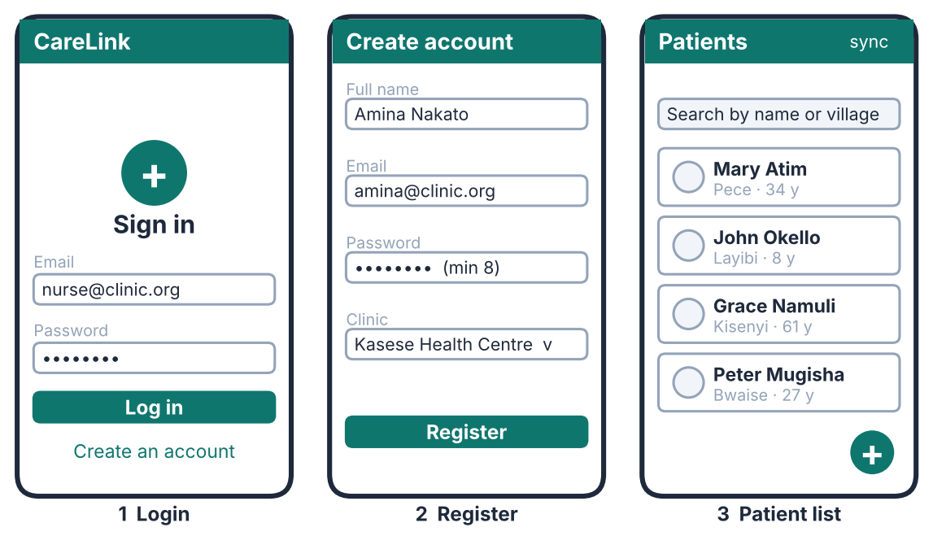
Figure 2. Authentication and patient list.
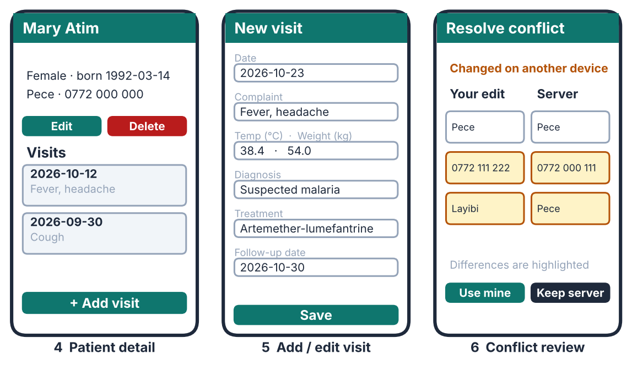
Figure 3. Patient detail, visit form and conflict review.
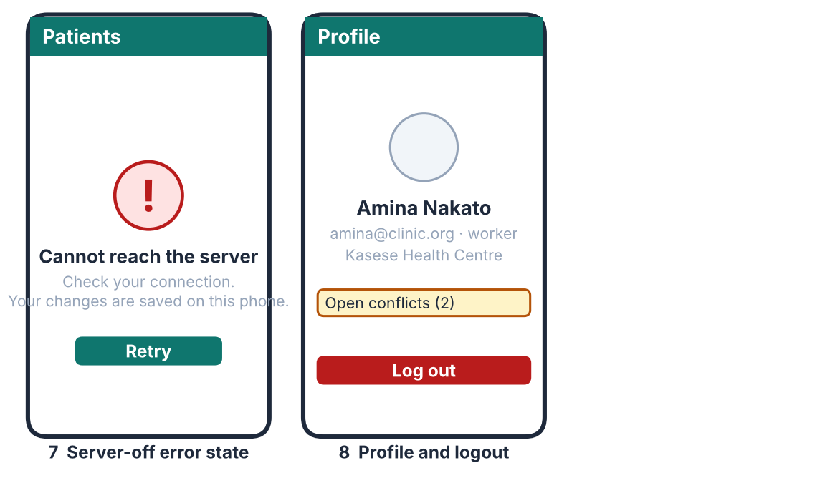
Figure 4. Server-off error state and profile with logout.
Navigation: Login ↔ Register; Login → Patient list → Patient detail → Visit form; Patient list → Profile (logout); any screen → Error state when the server cannot be reached; Profile → Conflict review.

9. Technology, Structure and Team Plan
Part | Choice
Mobile app | Flutter (Dart); http package; secure token storage; folders models/, services/, screens/, widgets/
Backend | FastAPI (Python); SQLAlchemy; bcrypt for passwords; JWT for tokens; automatic Swagger docs at /docs
Database | SQLite for development (PostgreSQL optional); tables exactly as in the ERD
Repository | backend/, app/, docs/ (this document, ERD image, API docs), top-level README

Date | Milestone
24 Oct | Design document submitted
8 Nov | Backend running: auth, CRUD, validation, docs
15 Nov | Flutter app connected to the backend
20 Nov | Final code and README submitted
23 Nov | Demo: register, login, create, view, edit, delete, conflict, with the ERD beside the real tables

